GiveStar supporter FAQs

Contents
GiveStar supporter FAQs 1
Why did Christian Aid choose GiveStar? 2
What options are available to us through GiveStar? 2
Does Givestar have QR codes? 2
What about other contactless devices you have tested previously? Eg GoodBox or the Thyngs QR codes? 2
Can my church use its own contactless device for Christian Aid? 2
Who can use the Givestar Contactless device? 2
Where do the devices work best? 2
What about public collections? (street/station/supermarket) 3
What about house-to-house? 3
But don’t other charities use contactless devices for street collections/ house-to-house? 3
Can the devices be used outside of Christian Aid Week? 3
Can a Christian Aid Group have a device? 3
Do I have to have a contactless device to use Givestar? 3
What are templates? 4
Technical questions – contactless devices 4
Can the device issue receipts? 4
Can TapSimple process Gift Aid? 4
Can someone give more than the £30 limit? 4
Can it be used to sign someone up to a regular gift? 4
What’s the platform fee? 4
How do Givestars online giving fees compare? 5
Can it work through wi-fi? 5
Can more than one person be linked to the device? 5
Will my church/Christian Aid group be credited with the amount raised? 5
How do churches sign up? 5
How will you support churches to get set up with the device? 5
My church is interested in using the device for our own church stewardship. How do I set that up? 6
How does the GiveStar service fee and the Square transaction fee affect my personal Gift Aid declaration? 6

Why did Christian Aid choose GiveStar?
In 2018 we realised that Christian Aid Supporters needed a contactless donation solution to address the increasingly cashless environment. In our testing we saw that contactless gifts worked best in settings like church collections, where people are expecting to give and there is a high level of trust and engagement. To be effective in this setting, devices need to allow donors to select a donation amount of their choice, and to include Gift Aid, all which GiveStar allows. It also allows you to see what you raised for different appeals like Christmas or Christian Aid Week.

What options are available to us through GiveStar?
Initially GiveStar launched with its low-cost contactless donation device. They have now expanded to encompass a full range of digital and cashless solutions including online fundraising pages, charity ticketing and livestream fundraising all supported by its user-friendly dashboard.

Does Givestar have QR codes?
The covid-19 pandemic has made QR codes much more common place and QR codes are integrated into GiveStar’s online giving pages and Virtual events. You can easily share your personal QR code on promotional literature, noticeboards, on leaflets distributed or online.

What about other contactless devices you have tested previously? Eg GoodBox or the Thyngs QR codes?
We’re not supporting the Thyngs QR codes as they didn’t perform well enough in testing. If you still have any of these, please destroy and dispose of them. Givestar has inbuilt QR codes for supporters to use.
We are unable to support other devices such as Goodbox.

Can my church use its own contactless device for Christian Aid?
Unfortunately, Christian Aid is currently unable to support churches to use their own contactless devices.
This is for a variety of reasons including being unable to match income raised to the organisation or individual fundraiser and needing to make sure that our branding is visible, and donors understand where their gift is going. Churches may struggle to identify the Christian Aid money from the church’s in their account and many options prevent donors from adding Gift Aid.

Who can use the Givestar Contactless device?
Any church or group can use the device. Larger Christian Aid groups or churches may find they have the most opportunities to use the devices, but we are keen to assist smaller churches in exploring how they can harness contactless technology and use this to make giving as easy as possible for their congregations. Anyone with a Givestar device will automatically be able to access the online and events fundraising tools on the Givestar dashboard.

Where do the devices work best?
They work best in places where people are expecting to give and there is a high level of trust and engagement. This includes places like church collections, concerts, quizzes, and other events.

What about public collections? (street/station/supermarket)
Our testing has shown that public collections are not good opportunities to use contactless – very few people will want to donate through them and it’s usually a small amount each time which doesn’t justify the cost of the device.
If you want to try using the devices at these collections in addition to a church collection or another event, that’s fine, but devices are best used in high engagement situations as described above.

What about house-to-house?
Like street collections, house-to-house collections are not a good opportunity to use the devices. We know that many people on the doorstop will say ‘Sorry, I’ve not got any cash’, but sadly that usually seems to be a polite no rather than indicating someone would give via contactless if that was available.
House-to-house is less well known than street collections, and as society changes many people are becoming less familiar with it. This means there are already sometimes trust barriers on the doorstep, which makes using a contactless device more difficult. Because of this, please don’t use the GiveStar devices for house-to-house. Instead, if someone doesn’t have cash you could suggest they give via caweek.org or text-to-donate, using the details found on the no reply slip.

But don’t other charities use contactless devices for street collections/ house-to-house?
You do occasionally see charities with contactless devices for street collections or even house-to-house, but that’s almost always for paid face-to-face fundraisers who are using them every day. We have tens of thousands of amazing volunteers for Christian Aid Week, and it just wouldn’t be cost effective to send them all a device, especially when it would only be used a few times a year.

Can the devices be used outside of Christian Aid Week?
Yes, we would encourage you to use these year-round to make the most of them. The more they are used, the easier you will find the device to handle. Christian Aid will offer different appeal screens for each key moment such as Harvest, Lent or Christmas and can quickly set new ones up for things like emergency appeals.

Can a Christian Aid Group have a device?
Yes! Note that the users will be set up to record donations against their Christian Aid Group. So, if the device is used by a church, say at a church service, the donations will be allocated to the Christian Aid Group and not the church.
It is possible for us to set it up so that the device can be used by more than one organisation. If you require this, please email hello@christian-aid.org
If there are big churches within the CAG it may be worth the individual churches requesting their own device, rather than trying to share one.

Do I have to have a contactless device to use Givestar?
Absolutely not, GiveStar has some fantastic digital tools on registration you will be asked what you’re interested in and at that point you can choose to request a device or not. All sign ups automatically get access to online giving and events fundraising, but you have the choice of which of the options you would like to explore and can navigate the platform at your own pace.

What are templates?
Christian Aid will create template giving pages for key moments like Harvest, Christmas and Christian Aid Week. If you are using an online fundraising page simply select Template in the online giving stream to see what’s available. We also create contactless campaigns for key moments so you can easily support Christian Aid week or Harvest for example with your device.

Technical questions – contactless devices

Can the device issue receipts?
Yes, if the enable contact after donation toggle is activated on the campaign card the donor can give their details and tick to receive an emailed receipt from GiveStar.

Can TapSimple process Gift Aid?
Yes – once someone has made a donation, they are given the option to fill in their details for Gift Aid. Gift Aid rates during testing were encouragingly high at 77%.

Can someone give more than the £100 limit?
Yes, as GiveStar also has chip and pin a supporter can choose an amount of their choice. Can it be used to sign someone up to a regular gift?
GiveStar does not currently support regular gifts.

What’s the platform fee?
There is a platform fee of 2.25%, which GiveStar gives the donor the option to cover. Most contactless devices and even websites like JustGiving will have this kind of fee and our testing has showed that most donors are happy to cover this cost. Online giving does not incur a platform fee.

How do Givestars online giving fees compare?
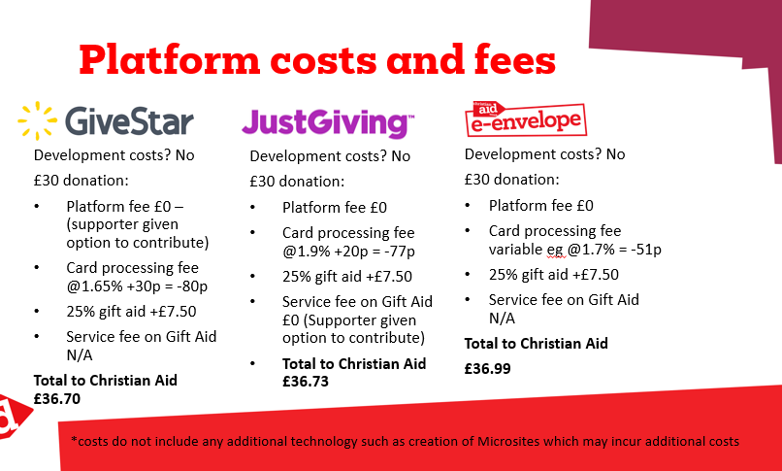
GiveStar like the other platforms we work with is extremely cost-effective way to give online. GiveStar offers supporters the option to contribute to the platform costs and our testing has showed that most donors are happy to cover this cost.

Can it work through wi-fi?
Yes.

Can more than one person be linked to the device?
Yes, more than one person can set up their phone with the two apps so it’s not dependent on one particular person being there with their phone.
No matter who is to use the device it’s important that they get set up and familiar with it ahead of the event. Once set up its pretty straightforward.

Will my church/Christian Aid group be credited with the amount raised?
Yes, when we set up each user, we assign you to what the GiveStar dashboard calls a “group” which is the name of your church or Christian Aid group. This enables us to directly process your fundraising to your church/Christian Aid group.

How do churches sign up?
Register at caid.org.uk/cashless. You will need to have a smart phone to use with the device.

How will you support churches to get set up with the device?
After registration you will receive two emails. An invitation to the GiveStar Dashboard where you can access all the fundraising tools. An email from Christian Aid with details of how to get started including the apps you need. GiveStar has lots of inbuilt support in the dashboard including a chat function should you get stuck.

My church is interested in using the device for our own church stewardship. How do I set that up?
You will need to contact Givestar directly at support@givestar.zohodesk.eu

How does the GiveStar service fee and the Square transaction fee affect my personal Gift Aid declaration?
The amount shown on your bank statement is the amount that you declare as charitable giving. So, if you donate £10 and don’t cover the (2.25%) Givestar fee then you declare £10. If you donate £10 and cover the GiveStar service fee, then you declare £10.23.

